BMA SHED PROJECT- PROPSAL ONE-

BACKYARD OUTFITTERS<INC

Treated and Painted Buildings-Built by Mennenites

Free delivery-we can purchase out right or just rent by month?

Website is [www.instantbarns.com](http://www.instantbarns.com)

Gary and I visited this site and found these buildings to be a quality item, material as well as construction.

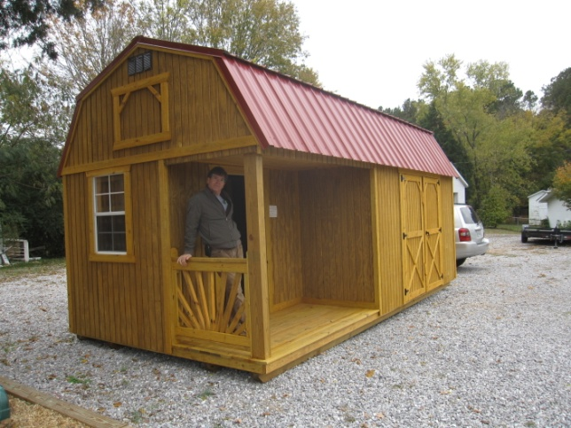 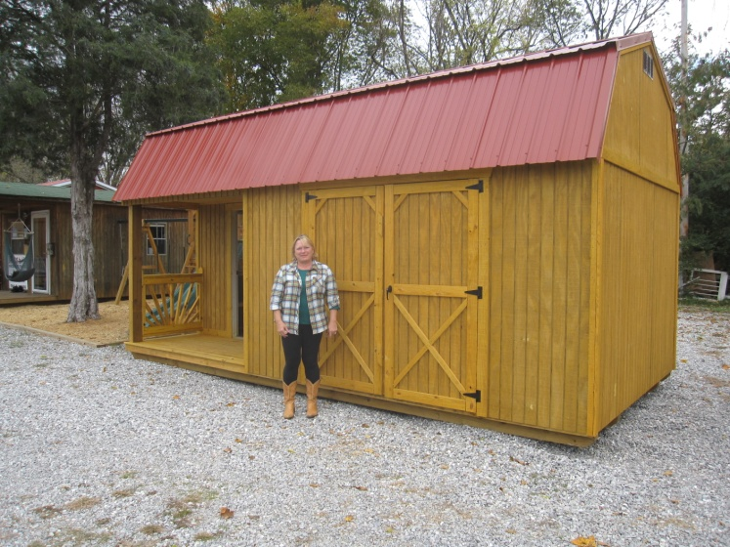

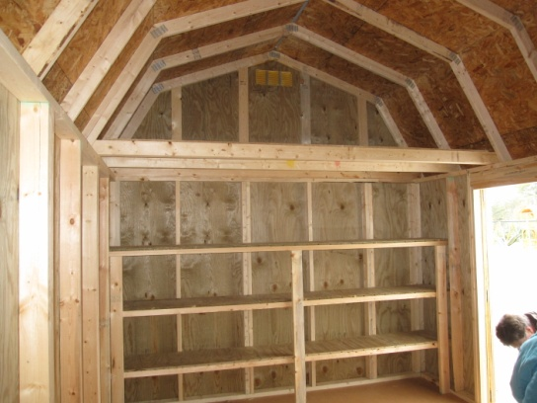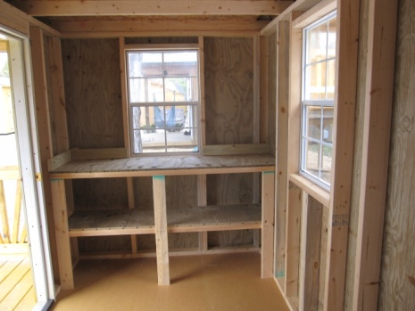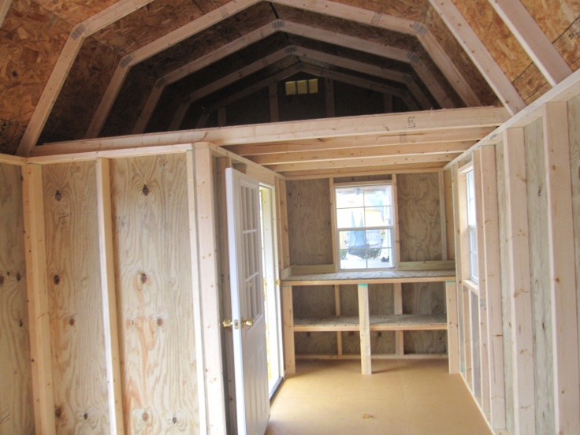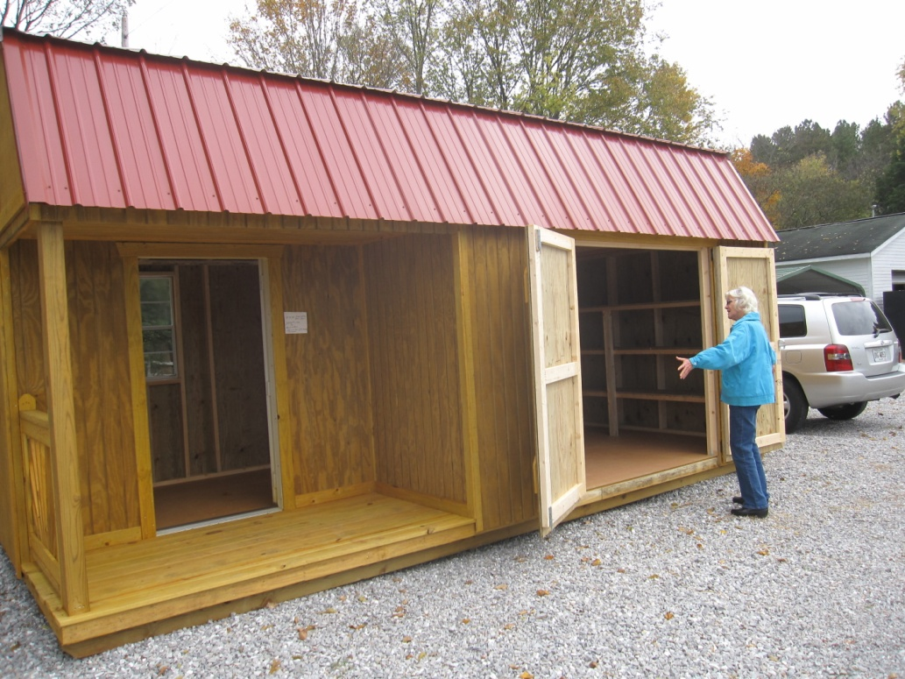

See this proposal one as being a solution to the immediate need to house two zero turn mowers.

We can also house any other blowers and future equipment we may need in the loft or on shelves.

Another really cool feature of this model is it could serve as a club house in the future or instantly! The beauty is we could add to our building in time by putting up insulation and sheet rock panels to make our building more homey. We could host pancake breakfasts and have some meetings there, as well as just a place for fly ins to have a place to rest and take shelter for a while? We could have water as well as electricity installed as we can.

We can place this building on a concrete slab, as well as, just concrete cinder blocks, for the immediate housing of the lawn mowers. Katie and Phil are wanting to be relieved of the mowers. They have housed and maintained these mowers for going on five years and would really appreciate it if we can come to some decisions as they are planning projects in their hangar and are in need of the space that the mowers currently house.

You are welcome to go to the website [www.instantbarns.com](http://www.instantbarns.com) and look at other buildings as well as sizes which go up to 40 feet long, if we want. The price of the building Gary and I saw is $5,210.00 which is 12 x 24. These prices include 2-2’x3’ Windows, 9 lite steel clad door, Double Barn Doors, Loft Workbench and 3 tier Shelves. We have the option of the color of metal roof as well as a choice of shingle colors. If we choose to rent this building. It will be $200.00 a month. The only reason for renting this building, that I can see , is if we just cannot get a decision at our meeting. Katie and Phil deserve for us to make a decision, but if not, we could always rent the building until we can come to some decision that we all are happy with. I will have the one brochure for reference at the meeting.

Location: Well, let’s just walk on over to where I see a potential building and you can make your decision when you come to the meeting. See you there.